PERMIS: PrivilEge and Role Management Infrastructure Standards

I. Introduction
In this chapter, we introduce PERMIS (PrivilEge and Role Management Infrastructure Standards) ^{[Wikipedia]} which is a policy-based authorization system for RBAC and present how to use it to implement an access control system. The PERMIS framework provides the necessary facilities for users to define and manage access control policies, assign privileges and roles to users, and make access control decisions and so on. For more details, please refer to the PERMIS web site.
PERMIS is an open source project, and Java source code is released under BSD License. The precompiled Java libraries can be found from the documentation (PERMIS Java). Its Java API enables PERMIS to be embedded into a wide class of applications such as Apache web server, Globus Toolkit, .Net, etc. PERMIS does not provide any authentication mechanism. Rather, it lets each application choose the authentication schemes and tools to use. Therefore, PERMIS's strength comes from its ability to be integrated into virtually any application and any authentication scheme like Shibboleth (Internet2), Kerberos, username/passwords, Grid proxy certificates and Public Key Infrastructure (PKI).
In addition to NIST standard model, PERMIS implements a hierarchical RBAC model, allows superior user roles to inherit the permissions of subordinate roles. PERMIS also provides the delegation issuing service, allowing users to delegate their privileges to other users according to the site’s delegation policy. PERMIS's main entities include an authorization policy, a set of users, a set of administrators (attribute authorities) who assign roles/attributes to users, a set of resources that are to be protected, a set of actions on resources, a set of access control rules, and optional obligations and constraints.
PERMIS provides a cryptographically secure privilege management infrastructure (PMI) using public key encryption technologies and X.509 Attribute certificates to maintain users' attributes. A PERMIS policy can be stored as either a simple text XML (eXtensible Markup Language) file, or as an attribute within a signed X.509 attribute certificate to provide integrity protection and tampering detection. The PERMIS policy has rules for user-role assignments and role-privilege assignments. User roles/attributes may be held in secure signed X.509 attributes certificates, and stored in Lightweight Directory Access Protocol (LDAP) directories or Web-based Distributed Authoring and Versioning (WebDAV) repositories, or they may be created on demand as Security Assertion Markup Language (SAML) attribute assertions.
PERMIS is based on a distributed architecture, you can refer to the What is PERMIS to understand what entities involved in this architecture and how they interact between entities. PERMIS also has abilities to support SAML attribute assertions, dynamic delegation of authority and separation of duties policies, and the recent addition of a controlled natural language interface (in English) for writing simple policies. PERMIS can work in either push mode (the user attribute assignments are sent to PERMIS by the application) or in pull mode (PERMIS fetches the attribute assignments itself from LDAP/WebDAV repositories or SAML attribute authorities).
The overall architecture of PERMIS Authorization Decision Engine is illustrated as shown in below Fig.1. The PERMIS authorization engine comprises two components: a Credential Validation Service (CVS) that validates users' roles according to the user-role assignment rules, and the Policy Decision Point (PDP) that evaluates users' access requests according to the role-permission assignment rules. Access to a resource depends upon the roles/attributes assigned to the user, and the role-permission assignments. The PERMIS PDP retrieves the policy and makes all decisions internally, hence no external agent can see the policy and only a grant/deny response returned to the application.
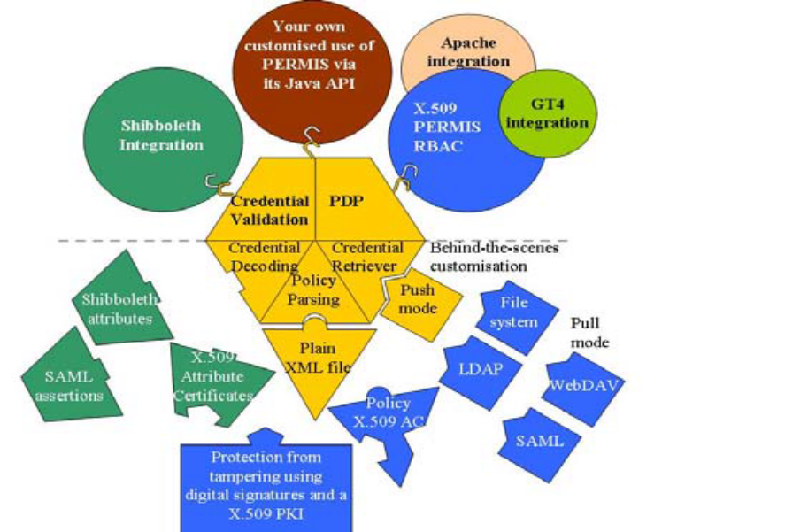
Figure 1: The PERMIS Authorization Decision Engine
To sum up, PERMIS is unique with its support for cryptographically protecting the user attributes/roles and the policy, which guarantees their integrity and protects them from being tampered with. The PERMIS authorization decision engine is superior to conventional PDPs since it has the ability to validate credentials and delegation chains, which is not a common capability of conventional PDPs, e.g. Sun’s XACML PDP. Furthermore it supports history based decision making and multi-session separation of duties. The XACML policy language is richer than that of PERMIS’s PDP policy, but XACML has not yet addressed the issue of credential validation and is only now working on dynamic delegation of authority.
Now that PERMIS is Open Source and anyone can contribute code to it, new features are continually being added to it. For more details, please refer to the Development Plans for PERMIS.

II. Building an Access Control System
In this section, we describe herein to show how to use a couple of tools offered by PERMIS to help you build an access control system. All the release of services by PERMIS can be found on the web (Download PERMIS).
For building an access control system, you may first go to download several releases of services that can perform a couple of functional components that are required. For example, an access control policy that defines the resources being protected and the rules controlling access to them needs to be created for governing data access, and the first release of services from PERMIS (Create a PERMIS policy) can help you to easily create the access control policy. Additionally, you may download "Installation Instructions", "Installation guide" or "Tutorial Materials" to refer or follow the individual instructions for successful installation and configuration.
According to an application example, e.g. "MeMDAS", we download and explain several releases of services offered by PERMIS for your reference of access control implementation.
Policy Creation
The PERMIS policy has rules for user-role assignments and role-privilege assignments, the latter containing optional obligations that are returned to the application when a user is granted access to a resource.
We assume that you have already downloaded the first release of services from PERMIS, the police editor (PE) can help you to compose and edit a PERMIS policy. Optionally, you can sign the policies and store them in an LDAP directory or local file stores. For users who are unfamiliar with X.500 directory servers and have no idea how to add user entries to the directory server, please refer to the following tutorial on the website, Add User Entries to Apache Directory Server . The Policy Editor can save the policy in XML format, or in X.509 Attribute Certificate format. The following paragraphs describe how to create a policy by PE toolkit.
Let's see what items included in top menu of PE to be edited and take MeMDAS policy as an example:
1. Policy Name: This policy has the unique name/identifier, e.g. "MeMDAS policy".
2. My Protected Resources: This section specifies the domains of resources that are covered by this policy, e.g. "patentRecordER".
3. Where Users Are From: This section specifies the domains where users are from. Only users from these domains will have access to the resources covered by this policy. The domain referenced, e.g. "SubjectDomainSpec" with the LDAP Distinguished Name starting at, e.g. "cn=Nurse, o=AAA, c=gb".
4. Role/Attribute Administrators: This section specifies the role/attribute administrators, e.g. "BB administrator", who are trusted to assign any roles of types "permisRole" to users who are from domain, e.g. "SubjectDomainSpec".
5. Role/Attribute Administrators Privileges: This section specifies the privilege of trusted role/attribute administrators whether the users have constraints on validity period or delegation depth.
6. User's Roles: This section specifies the roles used in this policy, and the hierarchical relationships between them. Superior roles inherit the privileges given to their subordinate roles.
7. Resources' Functions: This section specifies the functions that can be used on the resources, e.g. "Read" and "Write".
8. Roles' Privileges: This section specifies the privileges that are granted to users who have specific roles. In order for a user to be granted access to a resource, a user must have the roles specified in this section. If a user does not have the necessary roles, the requested access will be denied. For example, a user must have roles of type "eduPersonOrgUnitDN" with value "General Medicine" and roles of type "permisRole" with value "GraduateNurse" in order to perform action on resource in "patentRecordMed". A page similar to the one is as shown in below Fig2.

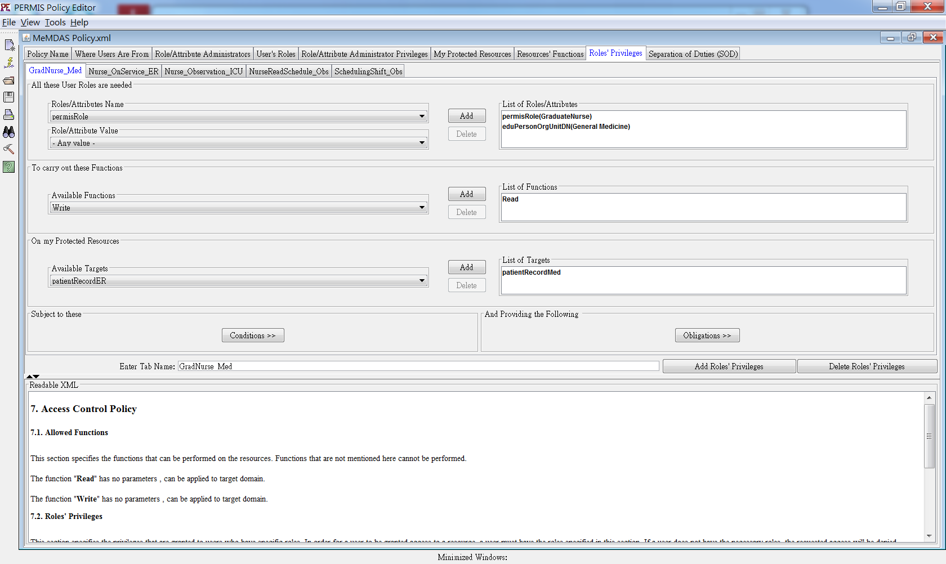
Figure 2: Compose an access control policy by PERMIS Policy Editor

The policy developers can create their PERMIS policy by editing described above items and save the policy. A policy file written in XML contains the full definition of roles in regard to protected resources and permissions related to a specific role. Referring to sample PERMIS policy (MeMDAS policy.xml), the PERMIS policy comprises the following components, and the definition of each component is as follows:
- SubjectPolicy: this specifies the subject domains i.e. only users from a subject domain may be authorized to access resources covered by the policy. Each domain is specified as an LDAP subtree, using Include DN and Exclude DN statements. For example:
<SubjectPolicy>
<SubjectDomainSpec ID="SubjectDomainSpec">
<Include LDAPDN="cn=Nurse, o=AAA, c=gb" />
</SubjectDomainSpec>
</SubjectPolicy>

- RoleHierarchyPolicy: this specifies the different roles and their hierarchical relationships to each other. For example:
<RoleHierarchyPolicy>
<RoleSpec OID="1.2.826.0.1.3344810.1.1.14" Type="permisRole">
<SupRole Value="Nurse">
<SubRole Value="GraduateNurse" />
</SupRole>
<SupRole Value="HeadNurse">
<SubRole Value="Nurse" />
</SupRole>
<SupRole Value="GraduateNurse" />
<SupRole Value="OnService" />
<SupRole Value="InCharge" />
<SupRole Value="Guest" />
</RoleSpec>
<RoleSpec Type="eduPersonOrgUnitDN" OID="1.3.6.1.4.1.5923.1.1.1.4">
<SupRole Value="General Medicine" />
<SupRole Value="Emergency Room" />
<SupRole Value="Obstetrics" />
<SupRole Value="Intensive Care Unit" />
</RoleSpec>
</RoleHierarchyPolicy>

- SOAPolicy : this specifies which SOAs are trusted to allocate roles. By including more than one SOA in this policy, the local SOA is trusting remote SOAs, and this enables the distributed management of roles to take place. For example:
<SOAPolicy>
<SOASpec ID="BB administrator" LDAPDN="cn=BB administrator, o=AAA,c=gb" />
</SOAPolicy>

- RoleAssignmentPolicy: this specifies which roles may be allocated to which subjects by which SOAs, whether delegation of roles may take place or not, and how long the roles may be assigned for. This sub-policy effectively states who is trusted to allocate which roles to whom, and is central to the distributed management of trust. For example:
<RoleAssignmentPolicy>
<RoleAssignment ID="RoleAssignment">
<SubjectDomain ID="SubjectDomainSpec" />
<RoleList>
<Role Type="permisRole" />
<Role Type="eduPersonOrgUnitDN" />
</RoleList>
<Delegate />
<SOA ID="BB administrator" />
<Validity />
</RoleAssignment>
</RoleAssignmentPolicy>

- TargetPolicy: this specifies the target domains covered by this policy. Each domain is specified as an LDAP subtree, using Include DN and Exclude DN statements or resources specified by HTTP-like URLs. For example:
<TargetPolicy>
<TargetDomainSpec ID="patientRecordMed">
<Include LDAPDN="cn=patientRecordMed, ou=General Medicine, o=AAA, c=gb" />
</TargetDomainSpec>
<TargetDomainSpec ID="patientRecordICU">
<Include LDAPDN="cn=patientRecordICU, ou=Intensive Care Unit, o=AAA, c=gb" />
</TargetDomainSpec>
<TargetDomainSpec ID="patientRecordER">
<Include LDAPDN="cn=patientRecordER, ou=Emergency Room, o=AAA, c=gb" />
</TargetDomainSpec>
<TargetDomainSpec ID="patientRecordObs">
<Include LDAPDN="cn=patientRecordObs, ou=Obstetrics, o=AAA, c=gb" />
</TargetDomainSpec>
<TargetDomainSpec ID="nurseSchedule_Med">
<Include LDAPDN="cn=nurseScheduleMed, ou=General Medicine, o=AAA, c=gb" />
</TargetDomainSpec>
<TargetDomainSpec ID="nurseSchedule_ICU">
<Include LDAPDN="cn=nurseScheduleICU, ou=Intensive Control Unit, o=AAA, c=gb" />
</TargetDomainSpec>
<TargetDomainSpec ID="nurseSchedule_ER">
<Include LDAPDN="cn=nurseScheduleER, ou=Emergency Room, o=AAA, c=gb" />
</TargetDomainSpec>
<TargetDomainSpec ID="nurseSchedule_Obs">
<Include LDAPDN="cn=nurseScheduleObs, ou=Obstetrics, o=AAA, c=gb" />
</TargetDomainSpec>
</TargetPolicy>

- ActionPolicy: this specifies the actions (or methods) supported by the targets, along with the parameters that should be passed along with each action. For example:
<ActionPolicy>
<Action ID="Read" Name="Read" />
<Action ID="Write" Name="Write" />
</ActionPolicy>

- TargetAccessPolicy: this specifies which roles have permission to perform which actions on which targets, and under which conditions. For example:
<TargetAccessPolicy>
<TargetAccess ID="GradNurse_Med">
<RoleList>
<Role Type="permisRole" Value="GraduateNurse" />
<Role Type="permisRole" Value="OnService" />
<Role Type="eduPersonOrgUnitDN" Value="General Medicine" />
</RoleList>
<TargetList>
<Target>
<TargetDomain ID="patientRecordMed" />
<AllowedAction ID="Read" />
</Target>
<Target>
<TargetDomain ID="nurseSchedule_Med" />
<AllowedAction ID="Read" />
</Target>
</TargetList>
</TargetAccess>
<TargetAccess ID="HeadNurse_Schedule_Obs">
<RoleList>
<Role Type="permisRole" Value="HeadNurse" />
<Role Type="permisRole" Value="OnService" />
<Role Type="eduPersonOrgUnitDN" Value="Obstetrics" />
</RoleList>
<TargetList>
<Target>
<TargetDomain ID="patientRecordObs" />
<AllowedAction ID="Read" />
<AllowedAction ID="Write" />
</Target>
</TargetList>
</TargetAccess>
</TargetAccessPolicy>

The PERMIS policy editor also can create XACML policies via the controlled natural language interface (the WRITE button). You need to install and configure the standalone server, which accepts XACML requests and allows an XACML PDP to plugged into it. The following PDP section in 2.3 will explain how to install and configure the standalone server in details.
Give A Privilege Attribute To Someone
We assume you already download the second release of services from The PERMIS (Give a privilege attribute to someone). The Attribute Certificate Manager (ACM) tool is used by administrators to allocate attributes to users in the form of X.509 Attribute Certificates(AC). These bind the issued attributes with the subject’s and issuer’s identities in a tamper-proof manner. X.509 fully supports hierarchical RBAC by allowing both roles and privileges to be inserted as attributes in a role specification AC, so that the latter role inherits the privileges of the encapsulated roles.
The ACM has a GUI interface that guides the manager through the process of Attribute Certificates creation, modification and revocation, a page similar to the one is as shown in below Fig3. For example of a signed AC case, the AC manager must add his digital signature to the AC if he already have a PKI key pair in PKCS#12 format, so the GUI prompts him for the PKCS#12 file holding his private key and his password to unlock it. Once the AC is signed, the manager has the option of storing it in an LDAP directory , WebDAV repository or local file store. The generated privilege information is stored in X.509 Attribute Certificate format.
After you start the ACM application , you may need to follow the installation guide ACM Installation Guide to configure and test the AC policy. Depending on the way you choose to store your AC file in an LDAP directory , WebDAV repository or local filestore, you can find the detailed procedures to perform acceptance tests. All available options of acceptance tests are listed as follows.
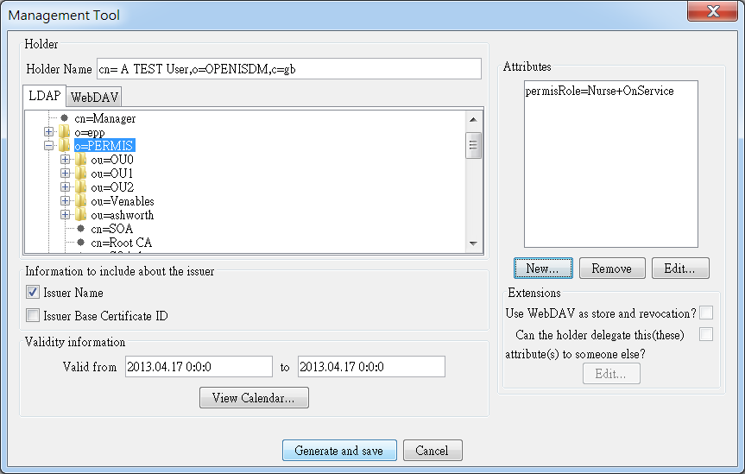
Figure 3: Bind the issued attributes with the subject’s and issuer’s identities by Attribute Certificate Manager

2.3 The PDP
You are assumed to be familiar with rudimentary concepts of PEP, PDP, relational databases and SQL for these key elements of constructing an access control systems. An important release service in PERMIS, "Install a standalone PERMIS authorization server"(download permis standalone authorization server), is a web service based authorization server to respond to an application's request for authorization related services such as an authorization decision, credential validation, and/or obligation enforcement.
To help you install and tailor this service to use in your own applications, we would like to describe more details about this service. It is a Java based application with an embedded Apache Axis2 service that accepts requests for authorization services using three standardized protocols messages sent using SOAP over HTTP or SOAP over HTTPS. The first of these protocol languages is an XACML request/response context. The second is a XACML over SAML and the final protocol is a Ws-Trust and SAML. This server supports the use of multiple policies when XACML over SAML or WS-Trust and SAML message handlers are queried.
Firstly, you need to install the Axis2 servlet in the servlet container, such as Apache Tomcat, by download the axis2.war and simply copy axis2.war to $TOMCAT/webapps directory. The best way to make sure that your system is running Apache Axis2 is to install and test both a service and a client. The process involves those steps, please refer to the following user guide, Apache Axis2 User's Guide. Furthermore, you will need to endorse the XML parsing libraries in Tomcat prior to installing this authorization service. This endorsed directory is not created by default, accordingly, you need to copy all the JAR files inside the distribution's "endorsed" directory such as $standalone/endorsed to the directory $TOMCAT/endorsed.
Apache Axis2 services come bundled as *.aar files, which contain all the pieces necessary to define the service, such as the necessary classes and libraries and the services.xml file that defines the service's behavior. You can install the service using the Web administration application, but to make things simple for now, copy the *.aar file into the Axis2 services directory. Besides, you need to edit "services.xml" file that is located META/services in that AAR (Axis2 Archive) file, e.g. AuthzService-webapp.aar, to reflect the location of the main configuration file of the service as well as the location of the log4j properties file. Please refer to the following steps:
- For extracting and modifying "services.xml" file in that AAR (Axis2 Archive) file, "AuthzService-webapp.aar" has to be changed its file extension from .aar to .jar, i.e "AuthzService-webapp.jar".
- After unzipping AuthzService-webapp.jar, the extracted "service.xml" file has to be modified to reflect the location of the main configuration file of the service such as permis.xml as well as the location of the log4j properties file. In the file of service.xml, there are two properties that need to be set, i.e. "configFile" and "log4JConfigFile" respectively. For example:
<parameter name="configFile">c:\MeMDAS\permis.xml</parameter>
<parameter name ="log4JConfigFile">./log4j.properties</parameter>

3. Overwrite the modified "service.xml" file and build the all folder to become a new file called "AuthzService-webapp.jar"
4. Now, "AuthzService-webapp.jar" has to be changed back to AAR (Axis2 Archive) file, i.e. from .jar to .aar, and here it will become "AuthzService-webapp.aar".
5. Place the file "AuthzService-webapp.aar" to the location as follow:
${Tomcat_HOME} \webapps\axis2\WEB-INF\services
For Windows platforms, the judgment of path for the these files of service.xml and permis.xml is different from the Linux platforms, so the suggestion is to change all the relative path into an absolute path when the application is run on the Windows platforms.
After you follow the above-mentioned instructions, you should be able to verify whether the service has been installed properly or not by navigating to http://localhost:8080/axis2/services. When you have not correctly endorsed the XML libraries in Tomcat, or either service.xml or permis.xml has errors, a page of showing Axis service's deployment faults will be displayed. In other words, a service named "AuthzService" has been deployed successfully when a page similar to the one is displayed below:
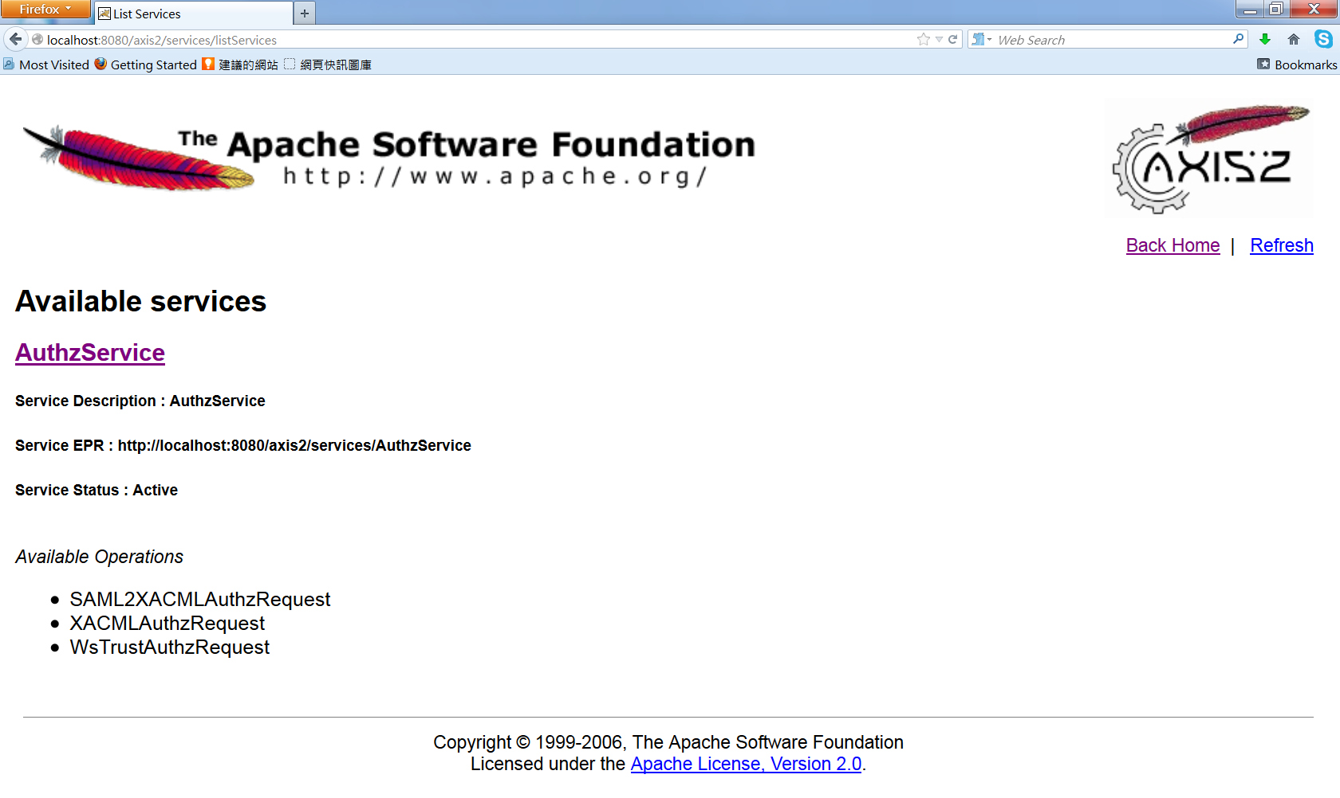
Policy Tester
The Policy Tester is a tool used to test PERMIS policies created by Policy Editor and Policy Wizard. Test cases can be created to simulate any users accessing any resources under any conditions, and the users will then be granted or denied access according to the specific PERMIS policy that is read into the Policy Tester. The test cases can be run in either single test mode or batch test mode. The result of running the tests are shown in the output window of the Policy Tester.
The PERMIS Policy Tester is a GUI designed to allow users to test a variety of different authorization decision requests against a fully functioning PERMIS decision engine without a PEP implementation. In this way the user can check if a PERMIS policy is returning the anticipated authorization decisions. The Policy Tester works by allowing the user to specify the subject, action, target and environment parameters of an authorization request, and to submit this request to a PERMIS policy decision engine configured with the user's chosen PERMIS policy.
Policy Tester currently supports both raw XML and AC protected PERMIS policies as well as text and AC based role attributes. Policy Test can be used to collect the subject ACs from an LDAP server or WebDAV server and push them to the PERMIS decision engine for it to perform X.509 signature verification on them. A page of Policy Tester is displayed below:
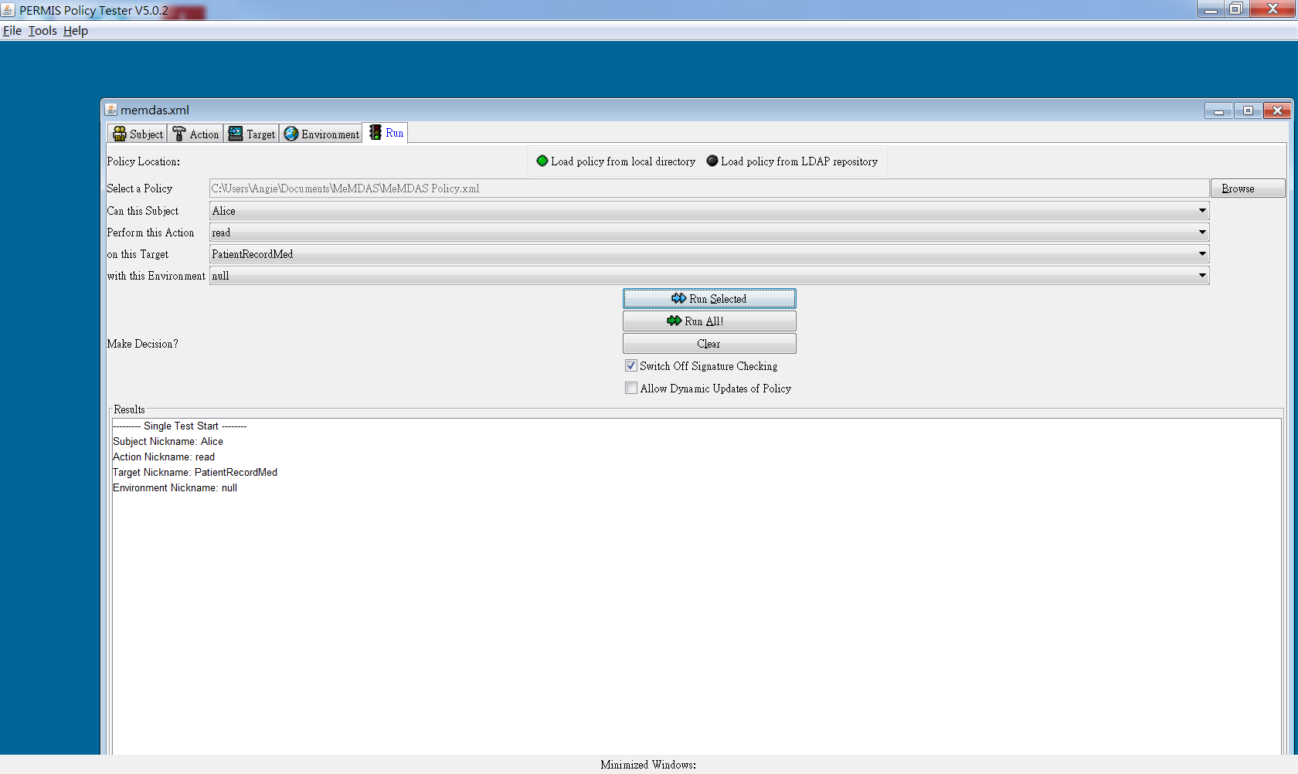

Access Control System Architecture
We have illustrated how the standalone PERMIS authorization server is used to serve as PDP to respond to an an appliction's, e.g. MeMDAS, request for an authorization decision in Fig.4. The policy stored in policy database (policy DB), determines which roles are to be trusted and what privileges are to be given to them. The policy is written in XML and provides the rules governing all aspects of access to the target resources, e.g. Electronic Medical Records (EMR) DB in the hospital.
When a user signs in the access control system and makes an access request to a resource. The request is received by a PEP. The PEP might check the user's credentials to see if the user has been authenticated. The PEP sends the request to the PERMIS standalone authorization server(PDP), and then the PDP checks the policies associated with the resource that the user wants to access. The PERMIS also provide credential validation service (CVS) for playing the function like policy information point (PIP). For example, the role assignment policy that state who is trusted to assign certain attributes to users. The CVS evaluates all credentials received against the role assignment policy, rejects untrusted ones, and forwards all validated attributes to the PEP. The PEP in turn passes these to the PERMIS PDP, along with the user's access request, and any environmental parameters. The PDP obtains an access control decision based on the target access policy, and sends its granted and denied response back to the PEP. Based on the decision, the PEP either permits or denies access to the user.
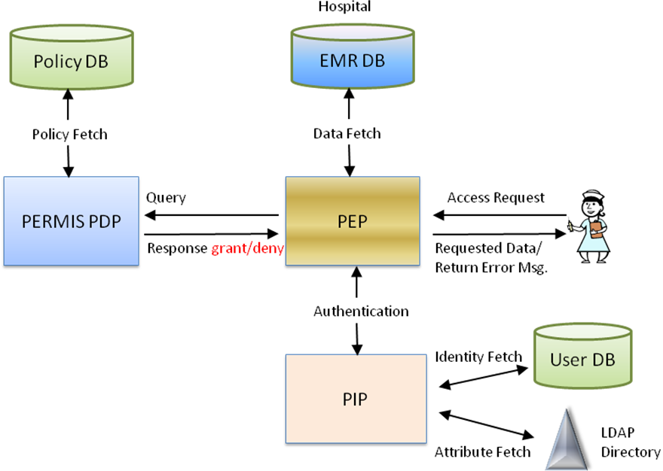
Figure 4. Access control system block diagram based on MeMDAS example

References
[1] David Chadwick, Chadwick, Gansen Zhao, Sassa Otenko, Romain Laborde, Linying Su, Tuan Anh Nguyen. "PERMIS: A Modular Authorization Infrastructure". Concurrency and Computation: Practice and Experience, 20(11):1341-1357, August 2008 Online ISSN: 1532-0634 [doi]. http://www.cs.kent.ac.uk/pubs/2008/2834/
[2] David Chadwick, Kaniz Fatema. "An Advanced Policy Based Authorisation Infrastructure". Proc DIM'09, November 13, 2009, Chicago, Illinois, USA. ACM
[3] David W Chadwick, Sassa Otenko and Tuan Anh Nguyen. "Adding Support to XACML for Multi-Domain User to User Dynamic Delegation of Authority". International Journal of Information Security. Volume 8, Number 2 / April, 2009 pp 137-152. DOI 10.1007/s10207-008-0073-y
[4] OASIS "eXtensible Access Control Markup Language (XACML) Version 2.0" OASIS Standard, 1 Feb 2005
[5] David W Chadwick, Linying Su, Romain Laborde. "Use of XACML Request Context to Obtain an Authorisation Decision". GFD.159. 13 November 2009. Available from http://www.ogf.org/documents/GFD.159.pdf
[6] David Chadwick, Linying Su. "Use of WS-TRUST and SAML to access a Credential Validation Service". GFD.157. 13 November 2009. Available from http://www.ogf.org/documents/GFD.157.pdf
[7] David W Chadwick, Alexander Otenko, Edward Ball "Implementing Role Based Access Controls Using X.509 Attribute Certificates – the PERMIS Privilege Management Infrastructure".
[8] Hasan Mahmud et. al. "Designing Access Control Model and Enforcing Security Policies Using PERMIS for a smart item E-health Scenario". International Journal of Engineering Science and Technology. Vol. 2(8), 2010, 3777-3787.

